Introduction & Problem Statement
Libraries are essential for learning and research, but managing them manually can be slow and error-prone. Keeping track of which books are available, who has borrowed what, and maintaining user records can quickly become confusing without a proper system.

The Library Management System (LMS) solves these problems by automating library tasks. It allows librarians to manage books, users, and transactions easily, keeping accurate records of borrowing and returning activities. Users can quickly find books and check availability, and the system provides a clear history of all transactions. Overall, it improves efficiency and reduces mistakes in everyday library operations.
Objectives
The main goal of this project is to build a Library Management System in C++ that makes managing books, users, and transactions simple and efficient.

The Specific Objectives of this Project Are:
- Book Management: Add, view, search, and sort books based on title, author, or ISBN.
- User Management: Add, view, and search users by ID or name, including phone numbers.
- Transaction Management: Keep a clear history of all borrowed and returned books with dates and user details.
- Data Import: Load initial datasets for books, users, and transactions from text files.
- Interface: Provide an easy-to-use, menu-driven interface.
- Validation: Prevent mistakes like returning books that were never borrowed or borrowing books that are already checked out.

Data Description & Source
The system starts with three main text files:
- books.txt: Contains book details – title, author, and ISBN.
- users.txt: Contains user details – ID, name, and phone number.
- transactions.txt: Contains previous transaction records – user ID, book ISBN, action (borrowed or returned), date, and user details.
These files allow the system to load initial data, so the library doesn’t have to start from scratch. New books, users, and transactions can also be added directly through the program.

Design
The system uses arrays to store books, users, and transactions. Each type of data is stored in a simple structure:
- Book: title, author, ISBN, availability
- User: ID, name, phone
- Transaction: user ID, ISBN, action, date, user name, phone
Functions handle all major operations like adding books or users, borrowing and returning books, displaying data, searching, sorting, and importing files. The program is menu-driven, making it easy for anyone to navigate.

Coding
The program is written in C++ and uses:
- Arrays for storing data
- Structs to organize book, user, and transaction information
- File handling to import initial datasets
- Functions for each task: add, borrow, return, display, search, sort, and import
- Automatic recording of the current date for transactions
- Linear search for finding books and users
- Bubble sort for sorting books
- Input validation to prevent errors, like borrowing unavailable books or returning books that weren’t borrowed
Code:
#include <iostream> // For input/output
#include <string> // For strings
#include <fstream> // For file operations
#include <ctime> // For getting date/time
#include <limits> // For numeric limits
using namespace std;

// Define the structure for a Book
struct Book {
string title; // Book title
string author; // Book author
string isbn; // Book ISBN code
bool available; // Is the book available to borrow?
};

// Define the structure for a User
struct User {
int id; // Unique user ID
string name; // User's name
string phone; // User's phone number
};

// Define the structure for a Transaction
struct Transaction {
int userId; // ID of the user performing the transaction
string isbn; // ISBN of the book
string action; // Borrowed or Returned
string date; // Date of the transaction
string userName; // Name of the user
string userPhone; // Phone number of the user
};

// Arrays to store books, users, and transactions
Book books[200];
User users[200];
Transaction transactions[400];

// Counters to track number of books, users, and transactions
int bookCount = 0;
int userCount = 0;
int transCount = 0;

// Function to get the current date in YYYY-MM-DD format
string getDate() {
time_t now = time(0); // Get current time
tm* t = localtime(&now); // Convert to local time structure
return to_string(1900 + t->tm_year) + "-" + // Year
to_string(1 + t->tm_mon) + "-" + // Month (0-based, so +1)
to_string(t->tm_mday); // Day
}

// Function to find a book by its ISBN
int findBook(string isbn) {
for (int i = 0; i < bookCount; i++) // Loop through all books
if (books[i].isbn == isbn) // If ISBN matches
return i; // Return index
return -1; // If not found, return -1
}

// Function to find a user by their ID
int findUser(int id) {
for (int i = 0; i < userCount; i++) // Loop through all users
if (users[i].id == id) // If ID matches
return i; // Return index
return -1; // If not found
}

// Function to add a new book manually
void addBook() {
cin.ignore(); // Clear input buffer
cout << "Enter title: ";
getline(cin, books[bookCount].title); // Read book title
cout << "Enter author: ";
getline(cin, books[bookCount].author); // Read book author
cout << "Enter ISBN: ";
getline(cin, books[bookCount].isbn); // Read ISBN
books[bookCount].available = true; // Mark book as available
bookCount++; // Increment book count
cout << "Book added." << endl; // Confirm addition
}

// Function to add a new user manually
void addUser() {
cout << "Enter user ID: ";
cin >> users[userCount].id; // Read user ID
cin.ignore(); // Clear input buffer
cout << "Enter name: ";
getline(cin, users[userCount].name); // Read user name
cout << "Enter phone: ";
getline(cin, users[userCount].phone); // Read phone number
userCount++; // Increment user count
cout << "User added." << endl; // Confirm addition
}

// Function to borrow a book
void borrowBook() {
int uid; // Store user ID
string isbn; // Store ISBN
cout << "Enter user ID: ";
cin >> uid; // Read user ID
cout << "Enter book ISBN: ";
cin >> isbn; // Read ISBN

int u = findUser(uid); // Find user index
int b = findBook(isbn); // Find book index

if (u == -1) { cout << "User not found." << endl; return; } // User validation
if (b == -1) { cout << "Book not found." << endl; return; } // Book validation
if (!books[b].available) { cout << "Book already borrowed." << endl; return; } // Already borrowed

books[b].available = false; // Mark book as borrowed
transactions[transCount].userId = uid; // Record user ID
transactions[transCount].isbn = isbn; // Record book ISBN
transactions[transCount].action = "Borrowed"; // Record action
transactions[transCount].date = getDate(); // Record current date
transactions[transCount].userName = users[u].name; // Store user name
transactions[transCount].userPhone = users[u].phone; // Store user phone
transCount++; // Increment transaction count

cout << "Book borrowed." << endl; // Confirm borrowing
}

// Function to return a book
void returnBook() {
int uid; // Store user ID
string isbn; // Store ISBN
cout << "Enter user ID: ";
cin >> uid; // Read user ID
cout << "Enter book ISBN: ";
cin >> isbn; // Read ISBN

int b = findBook(isbn); // Find book
if (b == -1) { cout << "Book not found." << endl; return; } // Validation
if (books[b].available) { cout << "This book was never borrowed." << endl; return; } // Cannot return available book

int u = findUser(uid); // Find user
if (u == -1) { cout << "User not found." << endl; return; } // Validation

books[b].available = true; // Mark book as available
transactions[transCount].userId = uid; // Record transaction
transactions[transCount].isbn = isbn;
transactions[transCount].action = "Returned";
transactions[transCount].date = getDate();
transactions[transCount].userName = users[u].name;
transactions[transCount].userPhone = users[u].phone;
transCount++; // Increment transaction count

cout << "Book returned." << endl; // Confirm return
}

// Display all books
void showBooks() {
cout << endl << "TITLE AUTHOR ISBN STATUS" << endl;
cout << "--------------------------------------------------------------" << endl;
for (int i = 0; i < bookCount; i++) { // Loop through all books
int tspace = (books[i].title.length() < 20 ? 20 - books[i].title.length() : 1); // Padding for title
int aspace = (books[i].author.length() < 20 ? 20 - books[i].author.length() : 1); // Padding for author
cout << books[i].title << string(tspace, ' ') // Print title
<< books[i].author << string(aspace, ' ') // Print author
<< books[i].isbn << " " // Print ISBN
<< (books[i].available ? "Available" : "Borrowed") << endl; // Print status
}
}

// Display all users
void showUsers() {
cout << endl << "ID NAME PHONE" << endl;
cout << "--------------------------------------" << endl;
for (int i = 0; i < userCount; i++) { // Loop through all users
int nspace = (users[i].name.length() < 20 ? 20 - users[i].name.length() : 1); // Padding for name
cout << users[i].id << " " // Print user ID
<< users[i].name << string(nspace, ' ') // Print name
<< users[i].phone << endl; // Print phone
}
}

// Display all transactions
void showTransactions() {
cout << endl << "DATE USER NAME PHONE ISBN ACTION" << endl;
cout << "--------------------------------------------------------------------------" << endl;
for (int i = 0; i < transCount; i++) { // Loop through all transactions
int nspace = (transactions[i].userName.length() < 20 ? 20 - transactions[i].userName.length() : 1); // Padding
cout << transactions[i].date << " " // Print date
<< transactions[i].userId << " " // Print user ID
<< transactions[i].userName << string(nspace, ' ') // Print user name
<< transactions[i].userPhone << " " // Print phone
<< transactions[i].isbn << " " // Print ISBN
<< transactions[i].action << endl; // Print action
}
}

// Import books from file
void importBooks() {
string file;
cout << "Enter books file name: ";
cin >> file;
ifstream fin(file); // Open file
if (!fin) { cout << "File not found." << endl; return; } // Check file

string title, author, isbn; // Temp vars
while (getline(fin, title, ',') && getline(fin, author, ',') && getline(fin, isbn)) {
books[bookCount].title = title; // Assign title
books[bookCount].author = author; // Assign author
books[bookCount].isbn = isbn; // Assign ISBN
books[bookCount].available = true; // New book available
bookCount++; // Increment count
}
fin.close(); // Close file
cout << "Books imported." << endl; // Confirm
}

// Import users from file
void importUsers() {
string file;
cout << "Enter users file name: ";
cin >> file;
ifstream fin(file);
if (!fin) { cout << "File not found." << endl; return; }

string id, name, phone;
while (getline(fin, id, ',') && getline(fin, name, ',') && getline(fin, phone)) {
users[userCount].id = stoi(id); // Convert and assign ID
users[userCount].name = name; // Assign name
users[userCount].phone = phone; // Assign phone
userCount++; // Increment count
}
fin.close();
cout << "Users imported." << endl;
}

// Import transactions from file
void importTransactions() {
string file;
cout << "Enter transactions file: ";
cin >> file;
ifstream fin(file);
if (!fin) { cout << "File not found." << endl; return; }

string id, isbn, action, date, name, phone;
while (getline(fin, id, ',') && getline(fin, isbn, ',') && getline(fin, action, ',') &&
getline(fin, date, ',') && getline(fin, name, ',') && getline(fin, phone)) {
transactions[transCount].userId = stoi(id); // Assign ID
transactions[transCount].isbn = isbn; // Assign ISBN
transactions[transCount].action = action; // Assign action
transactions[transCount].date = date; // Assign date
transactions[transCount].userName = name; // Assign name
transactions[transCount].userPhone = phone; // Assign phone

int b = findBook(isbn); // Find book
if (b != -1) { // If book exists
if (action == "Borrowed") books[b].available = false;
else if (action == "Returned") books[b].available = true;
}
transCount++; // Increment transaction count
}
fin.close();
cout << "Transactions imported." << endl;
}

// Search books
void searchBooks() {
int choice;
cout << "Search book by: 1. Title 2. Author 3. ISBN" << endl;
cout << "Choice: ";
cin >> choice;
cin.ignore(numeric_limits<streamsize>::max(), '\n'); // Clear buffer
string key;
cout << "Enter search keyword: ";
getline(cin, key);
bool found = false;
for (int i = 0; i < bookCount; i++) {
if ((choice == 1 && books[i].title.find(key) != string::npos) ||
(choice == 2 && books[i].author.find(key) != string::npos) ||
(choice == 3 && books[i].isbn.find(key) != string::npos)) {
cout << books[i].title << " | " << books[i].author
<< " | " << books[i].isbn
<< " | " << (books[i].available ? "Available" : "Borrowed") << endl;
found = true;
}
}
if (!found) cout << "No matching book found." << endl;
}

// Search users
void searchUsers() {
int choice;
cout << "Search user by: 1. ID 2. Name" << endl;
cout << "Choice: ";
cin >> choice;
cin.ignore(numeric_limits<streamsize>::max(), '\n'); // Clear buffer
bool found = false;
if (choice == 1) {
int uid;
cout << "Enter user ID: ";
cin >> uid;
int u = findUser(uid);
if (u != -1) {
cout << users[u].id << " | " << users[u].name << " | " << users[u].phone << endl;
found = true;
}
} else if (choice == 2) {
string key;
cout << "Enter name keyword: ";
getline(cin, key);
for (int i = 0; i < userCount; i++) {
if (users[i].name.find(key) != string::npos) {
cout << users[i].id << " | " << users[i].name << " | " << users[i].phone << endl;
found = true;
}
}
}
if (!found) cout << "No matching user found." << endl;
}

// Sort books
void sortBooks() {
int choice;
cout << "Sort books by: 1. Title 2. Author" << endl;
cout << "Choice: ";
cin >> choice;
for (int i = 0; i < bookCount - 1; i++) {
for (int j = i + 1; j < bookCount; j++) {
if ((choice == 1 && books[i].title > books[j].title) ||
(choice == 2 && books[i].author > books[j].author)) {
swap(books[i], books[j]); // Swap books
}
}
}
cout << "Books sorted." << endl;
}

// Main program
int main() {
int ch;
while (true) {
cout << endl << "==== LIBRARY SYSTEM ====" << endl;
cout << "1. Add Book" << endl;
cout << "2. Add User" << endl;
cout << "3. Borrow Book" << endl;
cout << "4. Return Book" << endl;
cout << "5. Show Books" << endl;
cout << "6. Show Users" << endl;
cout << "7. Show Transactions" << endl;
cout << "8. Import Books" << endl;
cout << "9. Import Users" << endl;
cout << "10. Import Transactions" << endl;
cout << "11. Search Books" << endl;
cout << "12. Search Users" << endl;
cout << "13. Sort Books" << endl;
cout << "0. Exit" << endl;
cout << "Choice: ";
cin >> ch;

if (ch == 1) addBook();
else if (ch == 2) addUser();
else if (ch == 3) borrowBook();
else if (ch == 4) returnBook();
else if (ch == 5) showBooks();
else if (ch == 6) showUsers();
else if (ch == 7) showTransactions();
else if (ch == 8) importBooks();
else if (ch == 9) importUsers();
else if (ch == 10) importTransactions();
else if (ch == 11) searchBooks();
else if (ch == 12) searchUsers();
else if (ch == 13) sortBooks();
else if (ch == 0) break;
else cout << "Invalid choice." << endl;
}
return 0; // Exit program
}
Test Cases:
Test Case | Input | Expected Output
Add Book | Title: "Python 101", Author: "Alice Smith", ISBN: "PY101" | Book is added and shows in the book list
Add User | ID: 501, Name: "Leo Carter", Phone: "555-0123" | User is added and shows in the user list
Borrow Book | User ID: 501, ISBN: "PY101" | Book marked as borrowed; transaction recorded
Borrow Already Borrowed | User ID: 502, ISBN: "PY101" | Program shows "Book already borrowed."
Return Book | User ID: 501, ISBN: "PY101" | Book marked as available; transaction recorded
Return Non-borrowed Book | User ID: 503, ISBN: "JS202" | Program shows "This book was never borrowed."
Search Book by Title | "Python" | Lists all books containing "Python" in the title
Search User by Name | "Leo" | Lists all users containing "Leo" in their name
Sort Books by Author | N/A | Books are displayed sorted alphabetically by author
Import Files | books_new.txt, users_new.txt, transactions_new.txt | Data loads; books’ availability updated correctly

Reflection and Analysis
- Using arrays was simple and worked well for a small number of records.
- Handling input carefully with getline() after cin was necessary to avoid errors.
- Keeping track of book availability and transaction history required careful logic, especially when importing transactions.
- Linear search and bubble sort were sufficient for the small dataset, though faster methods would be needed for large libraries.
- The project helped me understand file handling, structured programming, and menu-driven interfaces in C++.

Conclusion
The Library Management System successfully simplifies library management. It allows easy adding of books and users, borrowing and returning books, and tracking all transactions with accurate dates and user details. Searching and sorting features make it easy to find information quickly.
The system demonstrates practical use of C++ arrays, structs, and file handling. It is efficient for small-scale libraries and provides a foundation for future improvements like a GUI, dynamic data structures, or faster search and sort methods.

Improvements
- Use faster sorting methods, like merge sort, for large datasets.
- Replace fixed-size arrays with dynamic structures like vectors or linked lists.
- Add a GUI for better usability.
- Implement user authentication and role-based access.
- Automatically save updates to files so data persists between sessions.
- Include more advanced search and filtering options.

Final Note
This project is a fully functional Library Management System suitable for small libraries or as a teaching example. It automates key library operations, ensures accurate record-keeping, and demonstrates structured programming concepts in C++.

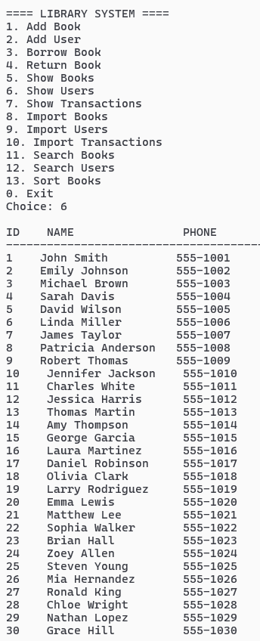
Dry Run:
Importing Books:
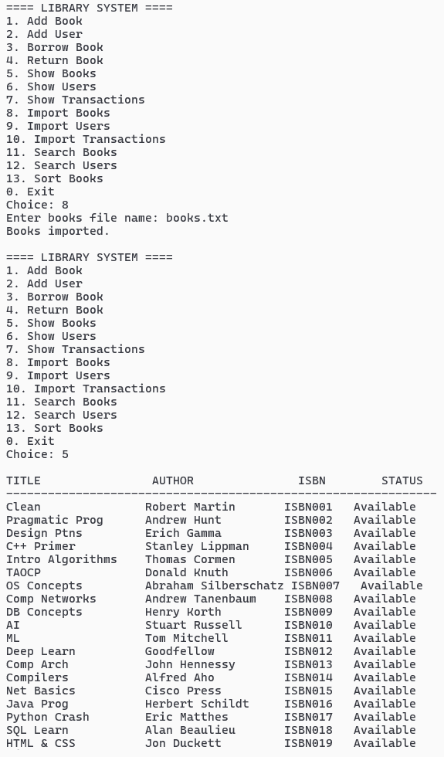
Importing Users:

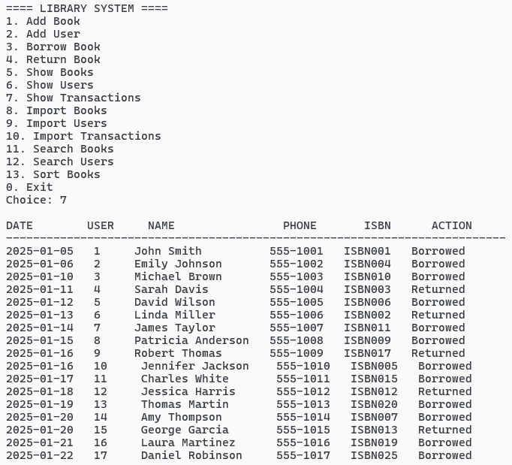
Importing Transactions:

Adding Book:
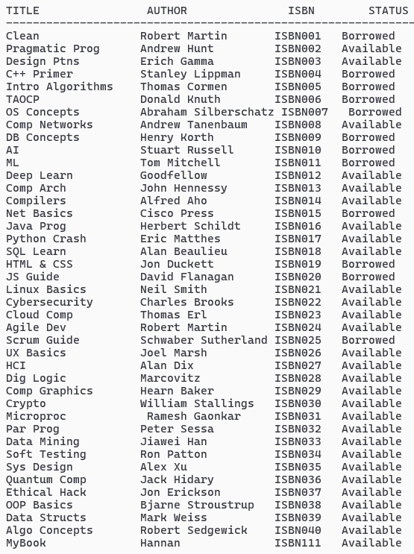
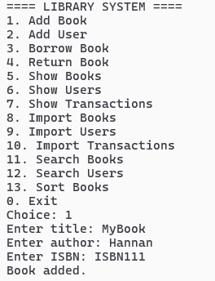
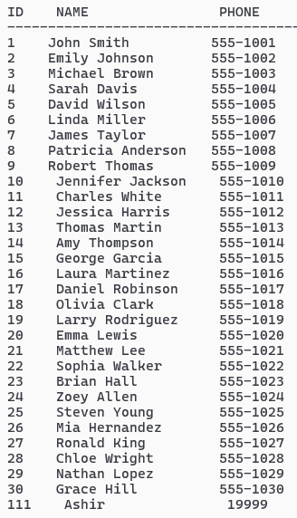
Adding User:
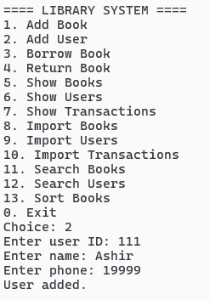
Borrowing Book:
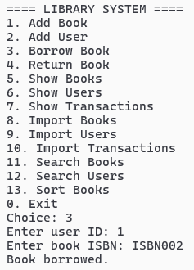 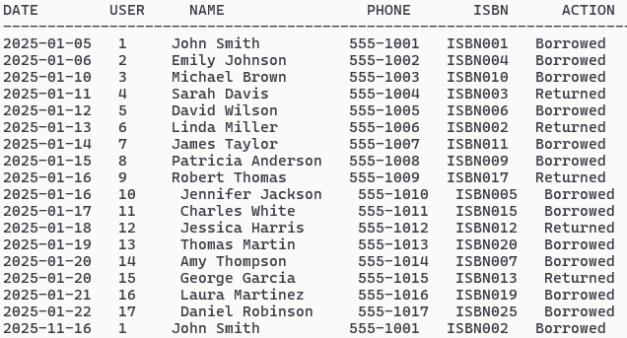

Returning Book:
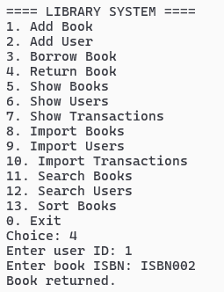
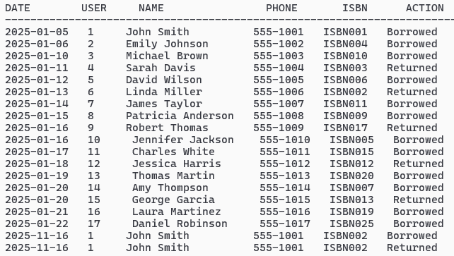
Search Book By Title:
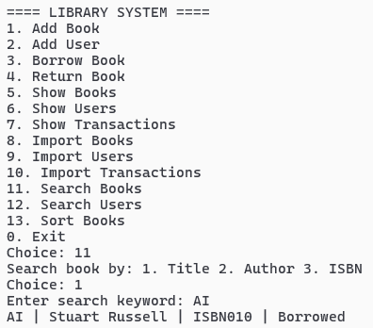
Search Book By Author:
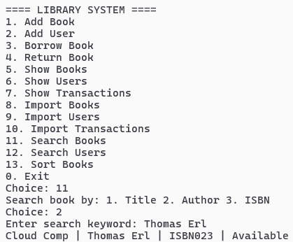
Search Book By ISBN:
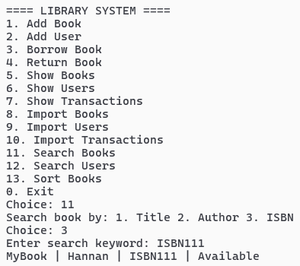
Search User By ID:
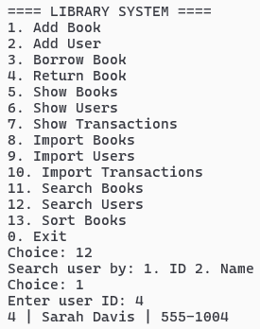
Search User By Name:
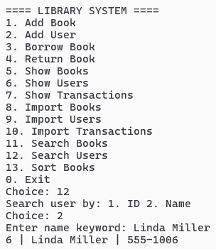
Sort Books By Title:
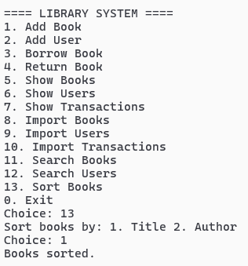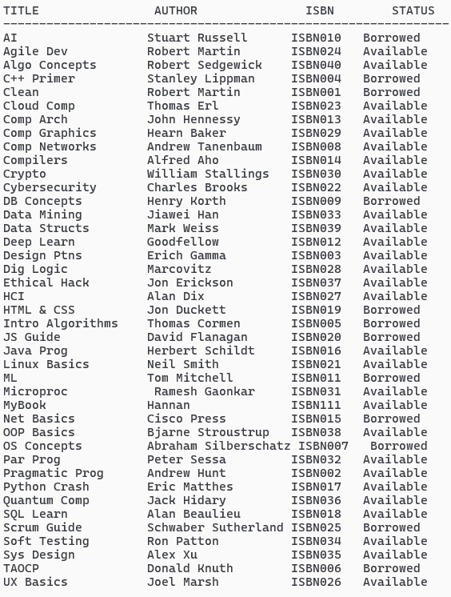
Sort Books By Author:
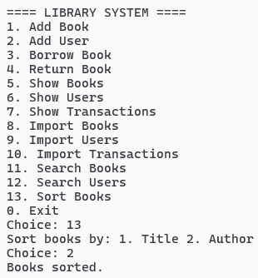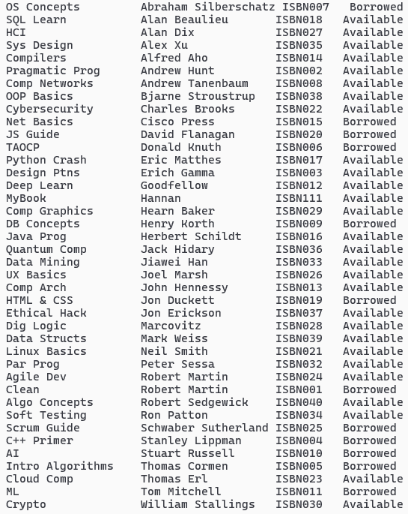
Borrowing An Already Unavailable Book:
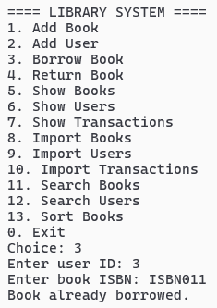
Returning A Book Never Borrowed:
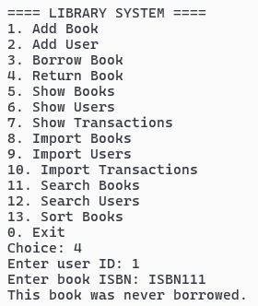
Exit Command:
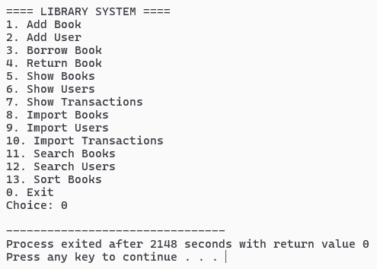
Raw Data:
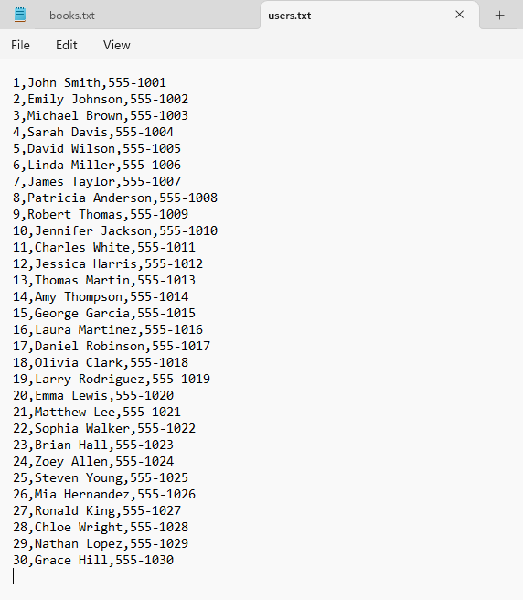
The raw data in our text files is stored in this form with each field separated by a separator, a comma in our case which helps our program import and extract this data into the program.
1. Introduction
The Library Management System (LMS) helps library staff manage books, users, and transactions like borrowing and returning books easily. The system has a menu-driven interface and allows importing data from text files, searching, sorting, and viewing records clearly. This manual will guide you through all features step by step, making it easy to operate the system efficiently.

2. System Features Overview
The LMS has three main sections:

2.1 Book Management
- 2.1.1 Add books manually
- 2.1.2 Import books from text files
- 2.1.3 View all books along with their availability
- 2.1.4 Search books by Title, Author, or ISBN
- 2.1.5 Sort books by Title or Author

2.2 User Management
- 2.2.1 Add users manually
- 2.2.2 Import users from text files
- 2.2.3 View all registered users
- 2.2.4 Search users by ID or Name

2.3 Transaction Management
- 2.3.1 Borrow books
- 2.3.2 Return books
- 2.3.3 View full transaction history
- 2.3.4 Import previous transactions
- 2.3.5 Transactions include date, user name, phone, and book details

3. Main Menu Navigation
When you start the program, a numbered menu appears. Simply type the number for the action you want to perform and press Enter. If you enter an invalid option, the system will give a clear error message and ask you to try again. The main menu options are:
- Add Book
- Add User
- Borrow Book
- Return Book
- Show Books
- Show Users
- Show Transactions
- Import Books
- Import Users
- Import Transactions
- Search Books
- Search Users
- Sort Books
- Exit

4. Book Management Instructions

4.1 Adding a Book
Choose option 1, then enter the Title, Author, and ISBN. The book is automatically marked as “Available” once added.

4.2 Importing Books
Prepare a text file with each line in this format: Title,Author,ISBN
Choose option 8, type the file name, and all books will be loaded into the system.

4.3 Viewing All Books
Select option 5 to see a complete list of books, showing Title, Author, ISBN, and availability status.

4.4 Searching Books
Choose option 11, then select whether you want to search by Title, Author, or ISBN. Enter your keyword, and all matching books will appear.

4.5 Sorting Books
Select option 13 to sort books either by Title or Author. The system will rearrange the list in ascending order.

5. User Management Instructions

5.1 Adding a User
Choose option 2, then enter the User ID, Name, and Phone Number. The user will be added to the system immediately.

5.2 Importing Users
Prepare a text file with each line in this format: ID,Name,Phone
Choose option 9 and type the file name. Users will be loaded into the system.

5.3 Viewing Users
Select option 6 to see a list of all users with their ID, Name, and Phone Number.

5.4 Searching Users
Choose option 12. You can search either by User ID (exact match) or Name (keyword search). Matching users will be displayed.

6. Transaction Management Instructions

6.1 Borrowing a Book
Select option 3 and enter the User ID and Book ISBN. The system checks if the user exists, the book exists, and the book is available. If all checks pass, the book is marked as “Borrowed,” and the transaction is recorded with the current date and user details.

6.2 Returning a Book
Select option 4 and enter the User ID and Book ISBN. The system ensures the book was actually borrowed and the user exists. The book is then marked “Available,” and the return transaction is recorded with the date and user details.

6.3 Viewing Transactions
Select option 7 to see all transactions. Each entry shows the Date, User ID, Name, Phone, Book ISBN, and whether the book was Borrowed or Returned.

6.4 Importing Transactions
Prepare a text file with each line: UserID,ISBN,Action,Date,UserName,Phone
Select option 10, type the file name, and all transactions will be imported. The system will automatically update the availability of the books based on the action.

7. Error Handling and Restrictions
The system prevents invalid actions such as:
- Borrowing a book that is already borrowed
- Returning a book that was never borrowed
- Using invalid User IDs or ISBNs
- Searching with invalid input
- Importing from missing or incorrectly formatted files
Clear messages guide you if any error occurs.

8. Tips for Smooth Use
- Import users before transactions to ensure data consistency
- Keep text files properly formatted, with no extra spaces
- Avoid duplicate User IDs or ISBNs
- Use sorting before searching for easier results

9. Summary
This manual covers all the Library Management System features. Following these instructions allows you to manage books, users, and transactions efficiently, whether adding data manually or importing from files. The system is designed to be user-friendly, reliable, and effective for small- to medium-sized libraries.

